Cypress Automation Training

Plural CODEMASH

Cypress: About 2

Cypress: Installation Steps 2

Cypress: Run Command 3

Cypress: Folder Structure 3

Cypress: Put in Action [Get Started] 4

Application Scenario 4

Cypress: Test writing scenarios (Lists) 6

Cypress: Steps for test writing (cypress code in action…) 7

Cypress Code Architecture 7

Simple Cypress Test Example 8

Cypress Test: add items 9

Removing Items 9

Implement Reset functionality 11

Reset using Writefile 12

Cypress Task: cypress/plugins 13

Async Request 14

# Cypress: About

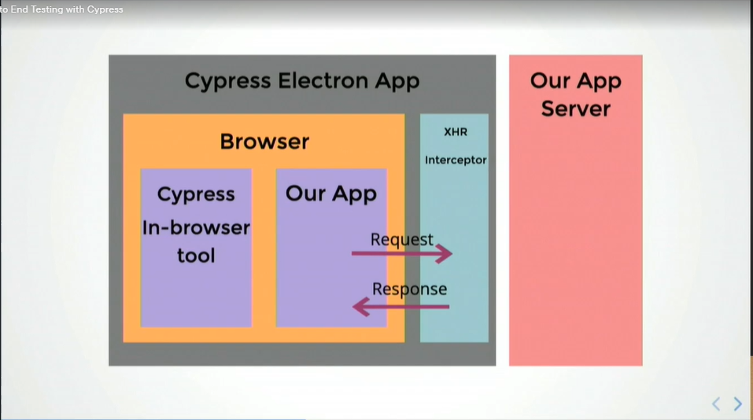

# Cypress: Installation Steps

npm install cypress save-dev

* It will generate cypress.json file
  + All cypress settings
* **cypress / integration** 
  + Contains all the test files named…. myFile.specs.ts
  + Putting all e2e (end to end tests)
  + We can organize accordingly by the creating new files, sub-folders etc…
  + All the tests should be integrated inside only “cypress >> integration” folder
* **cypress/fixtures**
  + use for mock data for certain scenarios in “cypress/fixtures”
* **cypress/plugins**
  + extending cypress functionality
  + use for writing certain tasks task to automate the things
  + can put all that code and keep it organized in the plugin folders, so its can extend Cypress’s features
* **cypress/support**
  + use for shared commands, utilities
  + we have a lot of common code where we can creating/removing/manipulating lots of dat. So, it’s a repeated code
  + we can abstract all that out and then put it in a util folder, which Cypress can also support

# Cypress: Run Command

npx cypress open

npx cypress run

# Cypress: Folder Structure

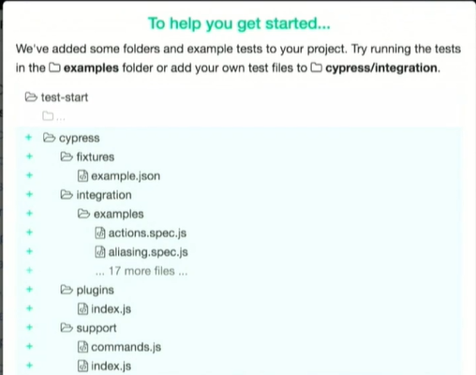

# Cypress: Put in Action [Get Started]

## Application Scenario

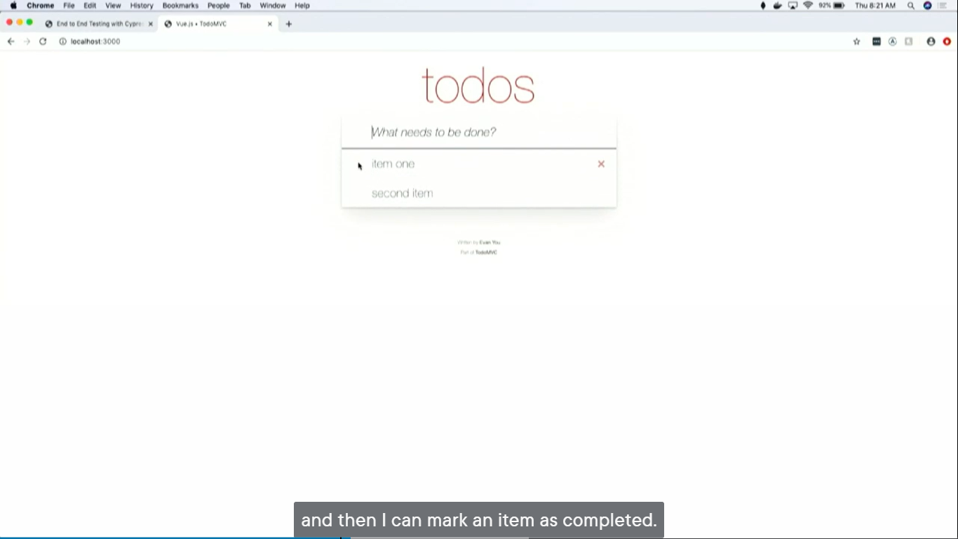

* can add items by write something in input text

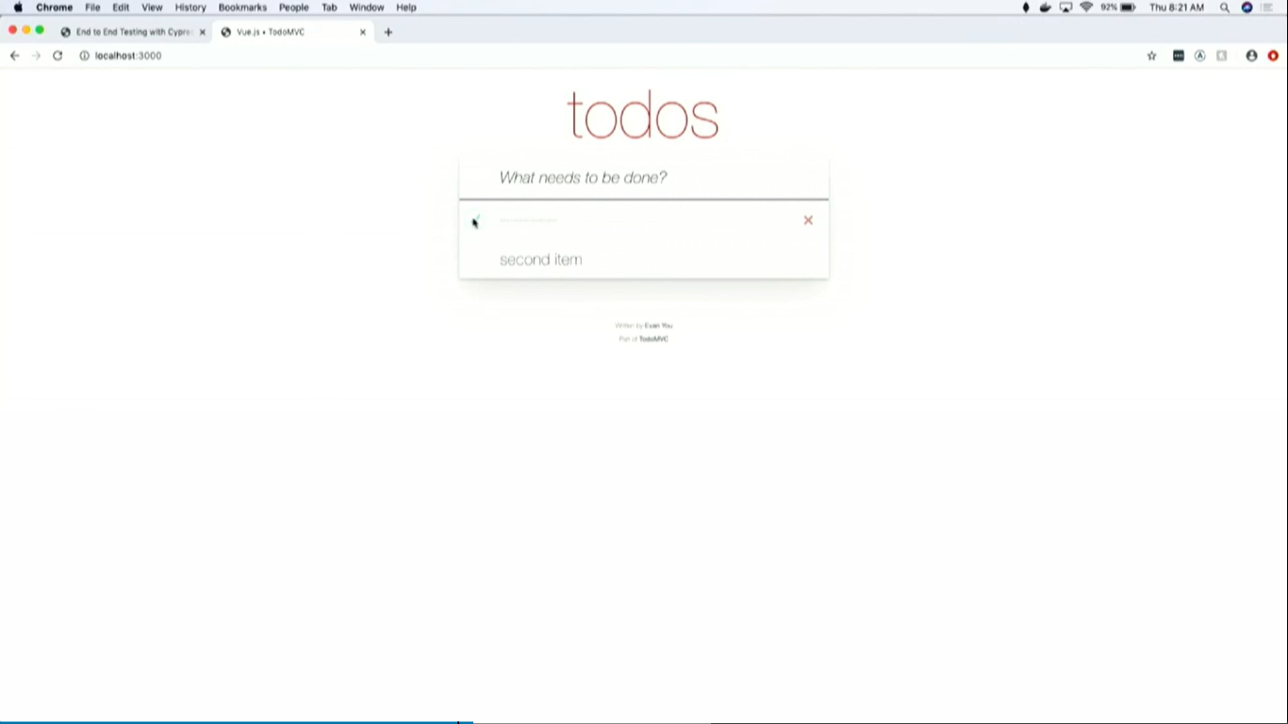

* can mark an as item has completed

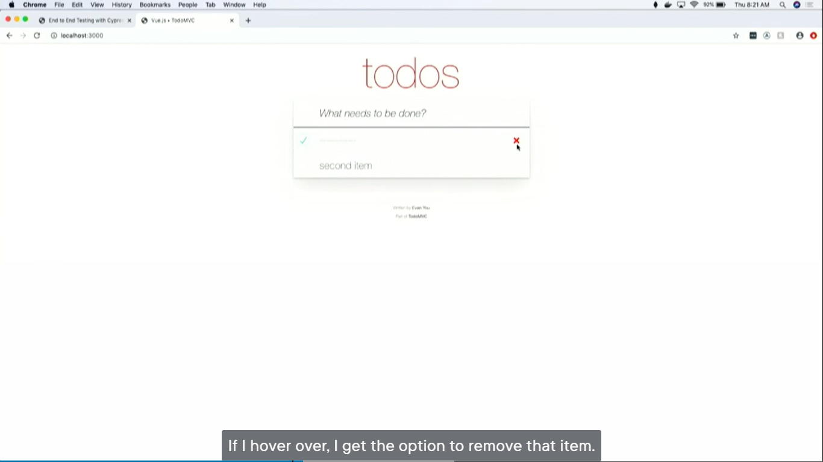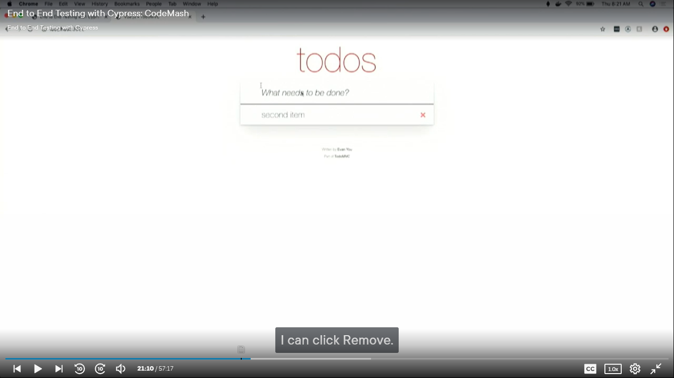

* on hoven there is option to remove that marked item
* can click to remove that item

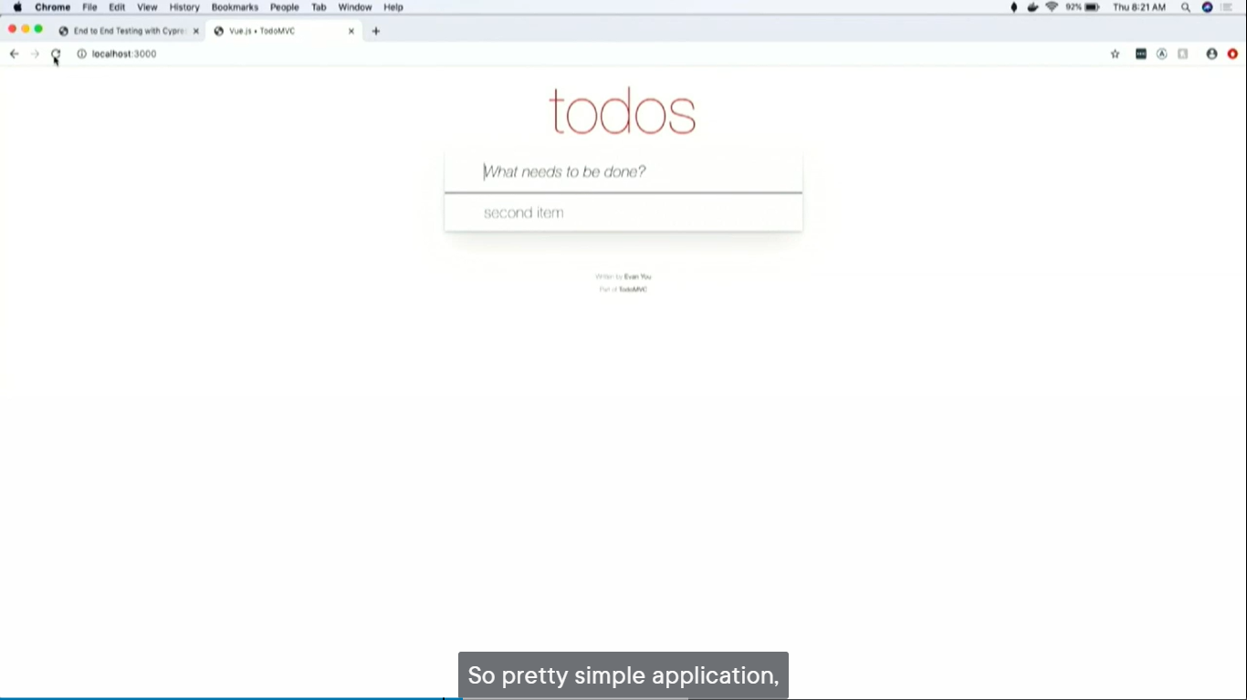

* when refresh, can get the item back

## Cypress: Test writing scenarios (Lists)

1. able to… add items
2. able to… mark things as a completed
3. able to… delete items
4. able to test… if certain requests are made
5. able to test… if loading elements are displayed
6. able to test… can I reset my state before each test runs?

## Cypress: Steps for test writing (cypress code in action…)

### Cypress Code Architecture

1. **Writing a smoke test**

// describe: Test suite name

***describe****('My first test', () => {*

// it: Verifies that application is loading. so we wrap it in ‘it’, and give it a name, and you pass a function

***it****('the home page loads', ()=> {*

// visit the URL

***cy.visit****('localhost:4200')*

// use ('selector', 'text') arguments

***cy.contains****('h1', 'todos')*

// Instead of hardcoding a string can use regular expression to look for things that we’re trying to serve

// but this kind of tests are problematic, as that would be a failure, but there’s going to be a subtle (indirect) failure

// but the moment if add other ‘h1’ to my homepage, this is going to break

***cy.contains****('h1', '^todos$/)*

// good practices is to use data-cy

// attributes specifically for testing

// data-cy = attribute element

// ‘app-title’ = id of an element …for easily query for exact element using data-cy property

***cy.contains****('[data-cy=app-title]', 'todos')*

})

})

#### Simple Cypress Test Example

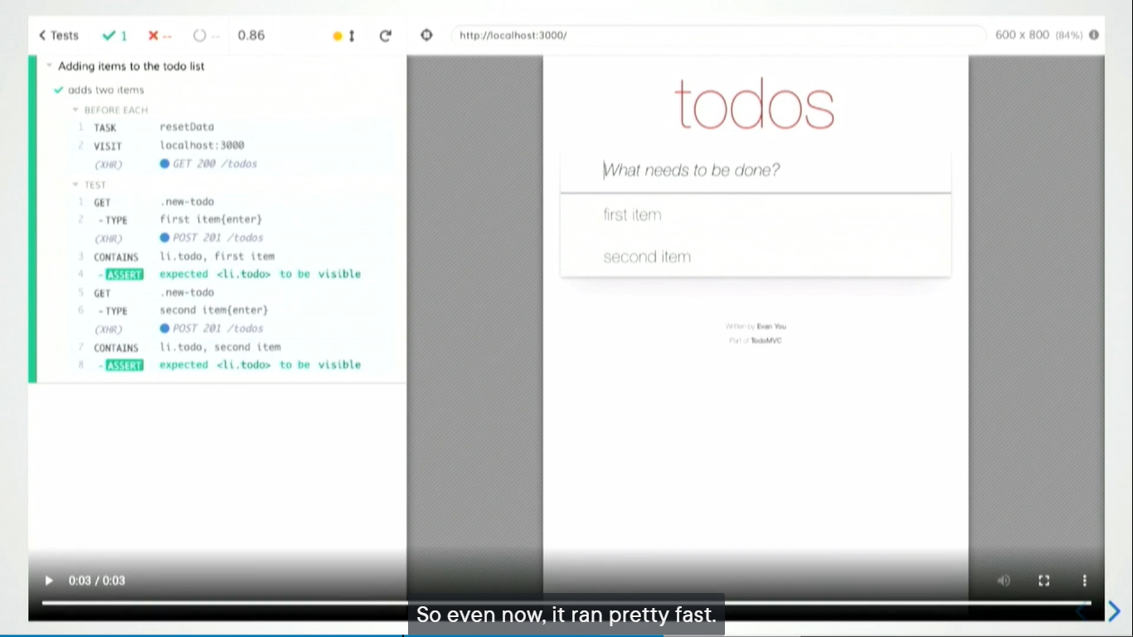

**// Simple Cypress test**

*describe('Adding items to the todo list', => (){*

*it('add two items',()=>{*

*cy.visit('localhost:3000')*

*cy.get('.new-todo').type('first item{enter}')*

*cy.contains('li.todo', 'first item').should('be.visible')*

*cy.get('.new-todo').type('second item{enter}')*

*cy.contains('li.todo', 'scond item').should('be.visible')*

*})*

*})*

**// Refactor Opportunity: if page is visiting every single time**

*describe('Adding items to the todo list', => (){*

***beforeEach(()=>{***

***cy.visit('localhost:3000')***

***})***

#### Cypress Test: add items

**//Add items**

*it('add two items',()=>{*

*cy.get('.new-todo').type('first item{enter}')*

*cy.contains('li.todo', 'first item').should('be.visible')*

*cy.get('.new-todo').type('second item{enter}')*

*cy.contains('li.todo', 'scond item').should('be.visible')*

*})*

*})*

#### Removing Items

**//Removing items**

describe('Adding items to the todo list', => (){

beforeEach(()=>{

cy.visit('localhost:3000')

})

//Add items

it('add two items',()=>{

cy.get('.new-todo').type('first item{enter}')

cy.contains('li.todo', 'first item').should('be.visible')

cy.get('.new-todo').type('second item{enter}')

cy.contains('li.todo', 'scond item').should('be.visible')

})

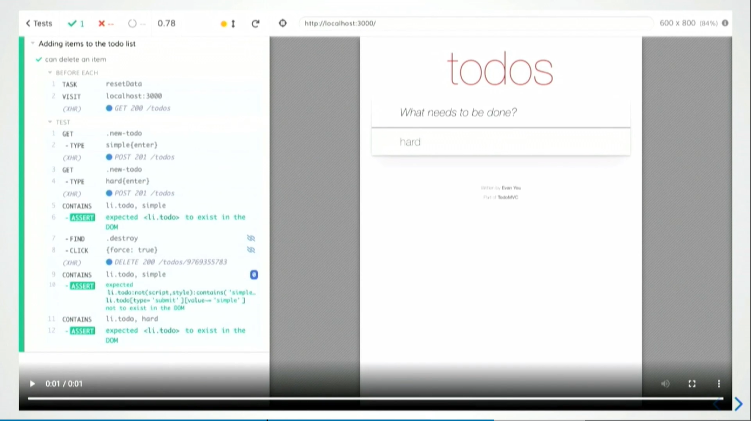

**// removing items**

*if('Can delete item',()=>{*

*//add few items*

*addItem('simple')*

*addItem('hard')*

*//delete first item*

*cy.contains('li.todo', 'simple')*

*.should('exist')*

*.find('.destroy')*

*//use force: true ...bacause we dont want hover*

*.click({*

*force:true*

*})*

*// confirm the deleted item is goe from the dom*

*cy.contains('li.todo','simple').should('not.exist')*

*// confirm the other item still exist*

*cy.contains('li.todo,'hard').should('exist')*

*})*

*})*

#### Implement Reset functionality

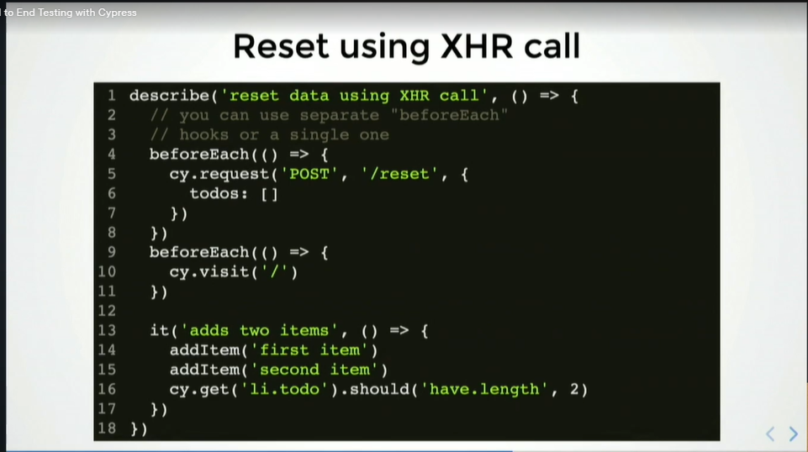

*beforeEach(()=>{*

*cy.request(‘POST’, ‘/reset’,{*

*todos: []*

*})*

*})*

#### Reset using Writefile

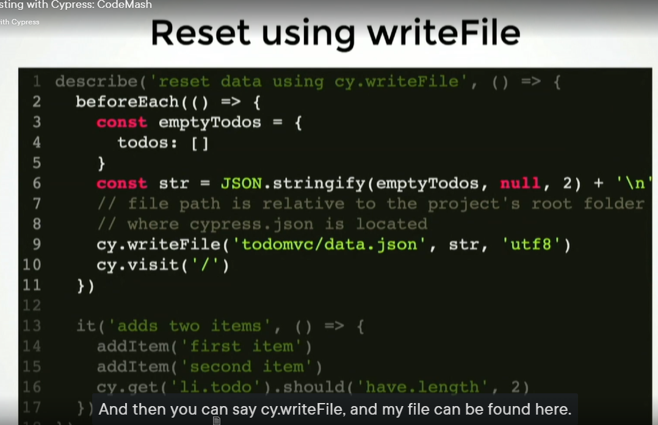

#### Cypress Task: cypress/plugins

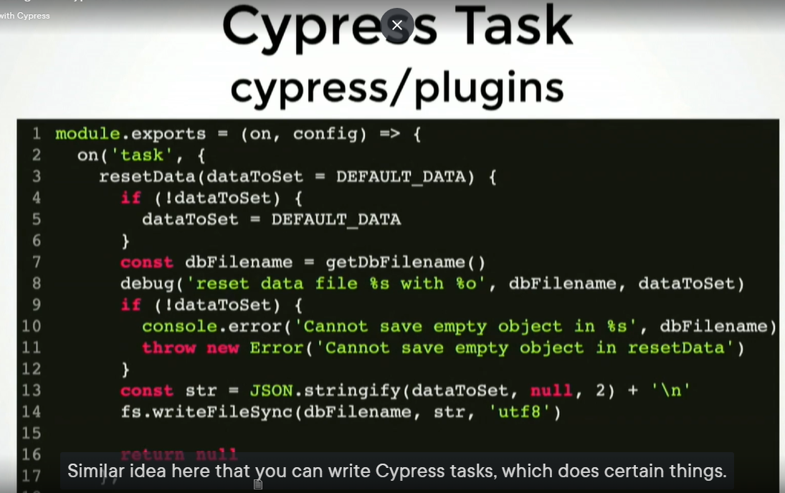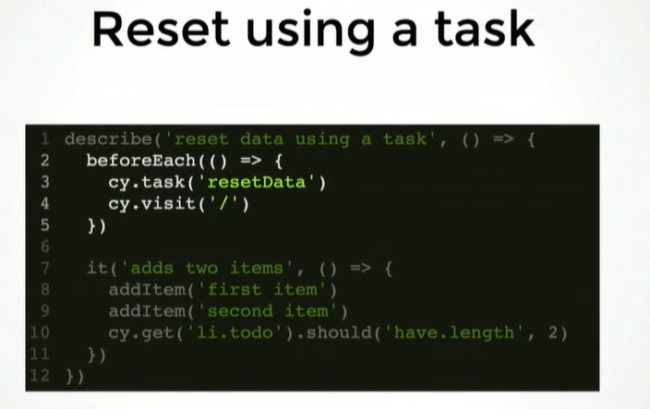

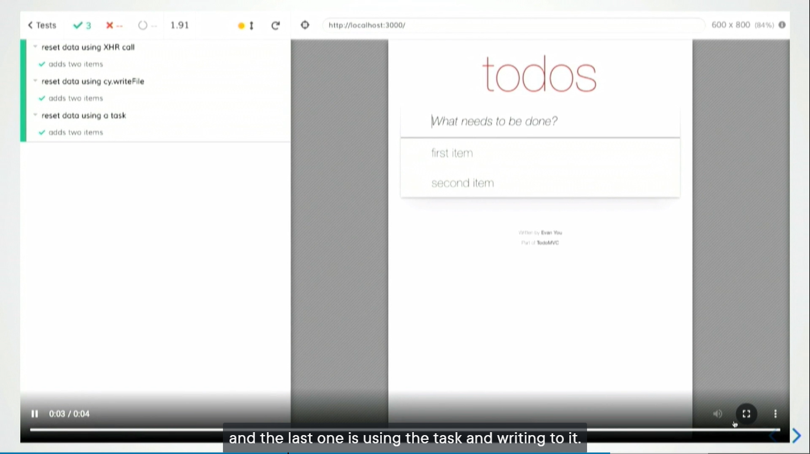

#### Async Request (using spies)

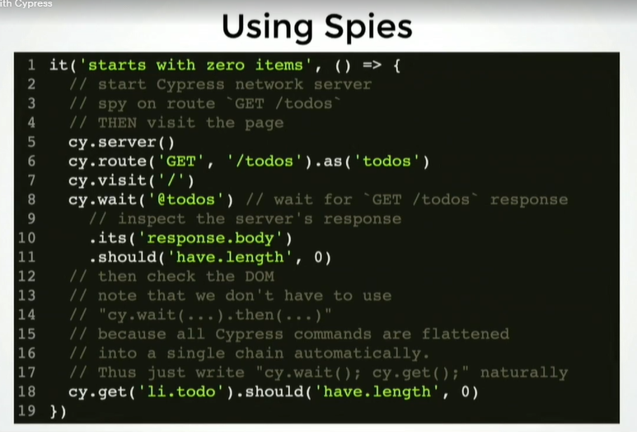

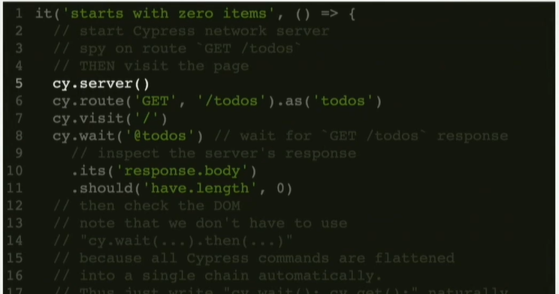

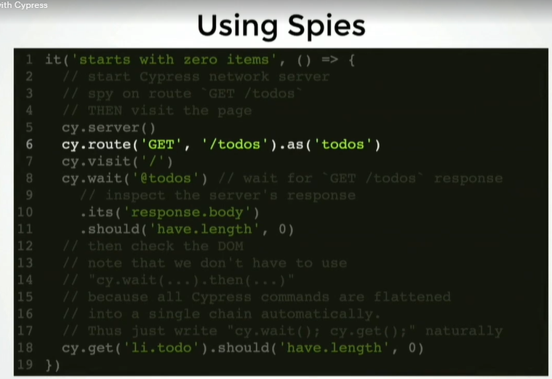

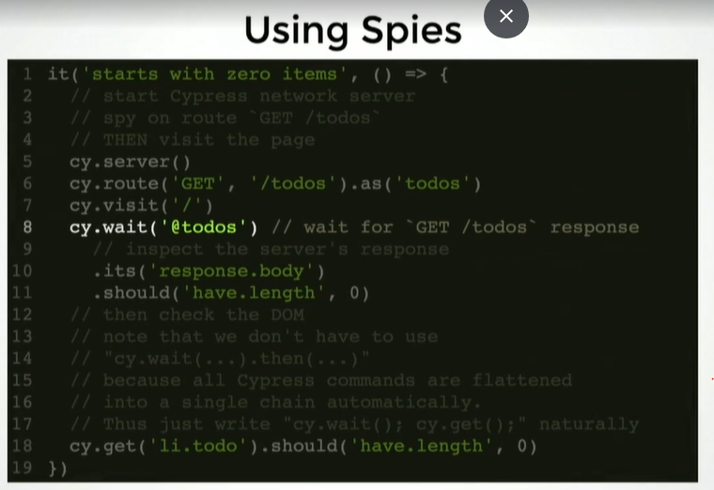

#### Using Stub

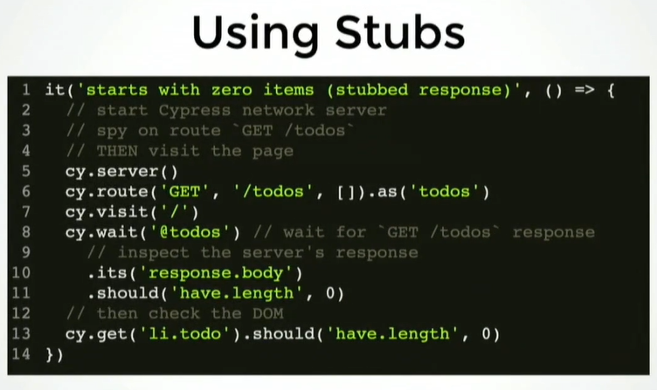

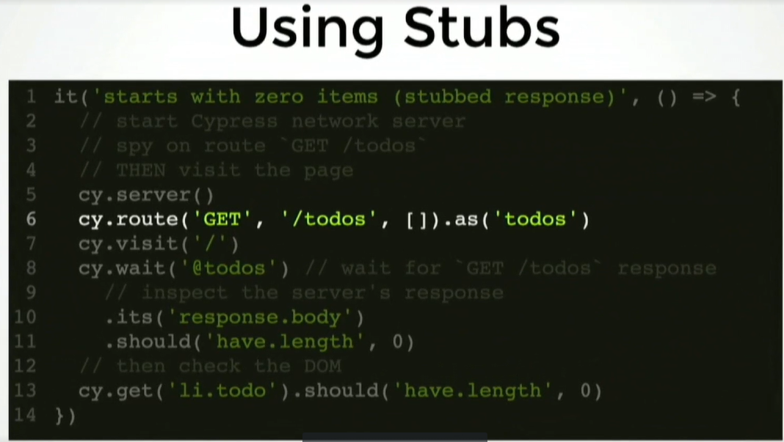

#### Stub using a fixture

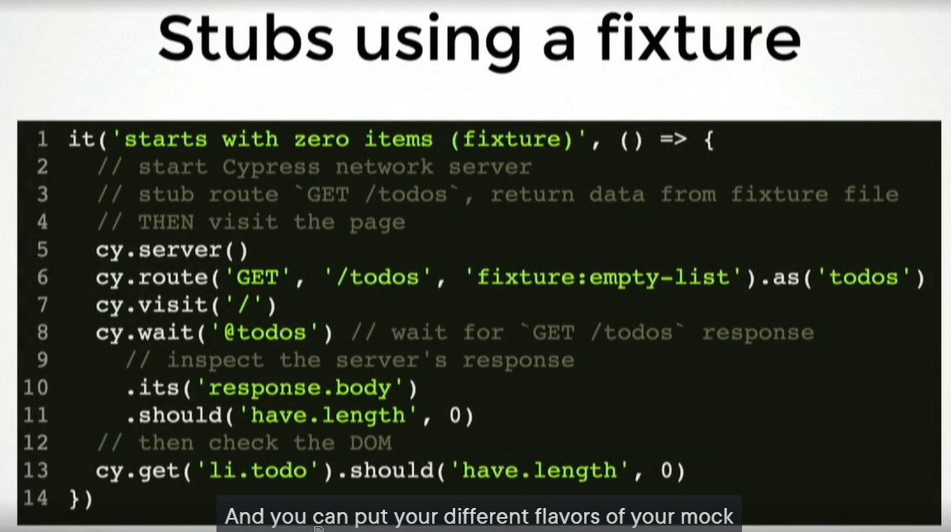

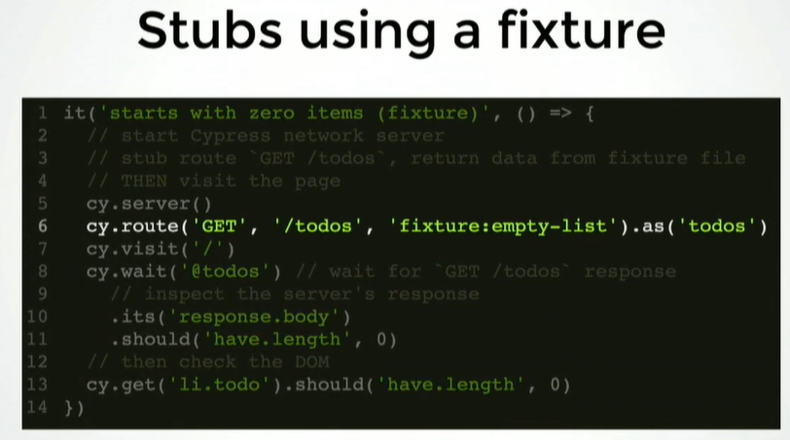

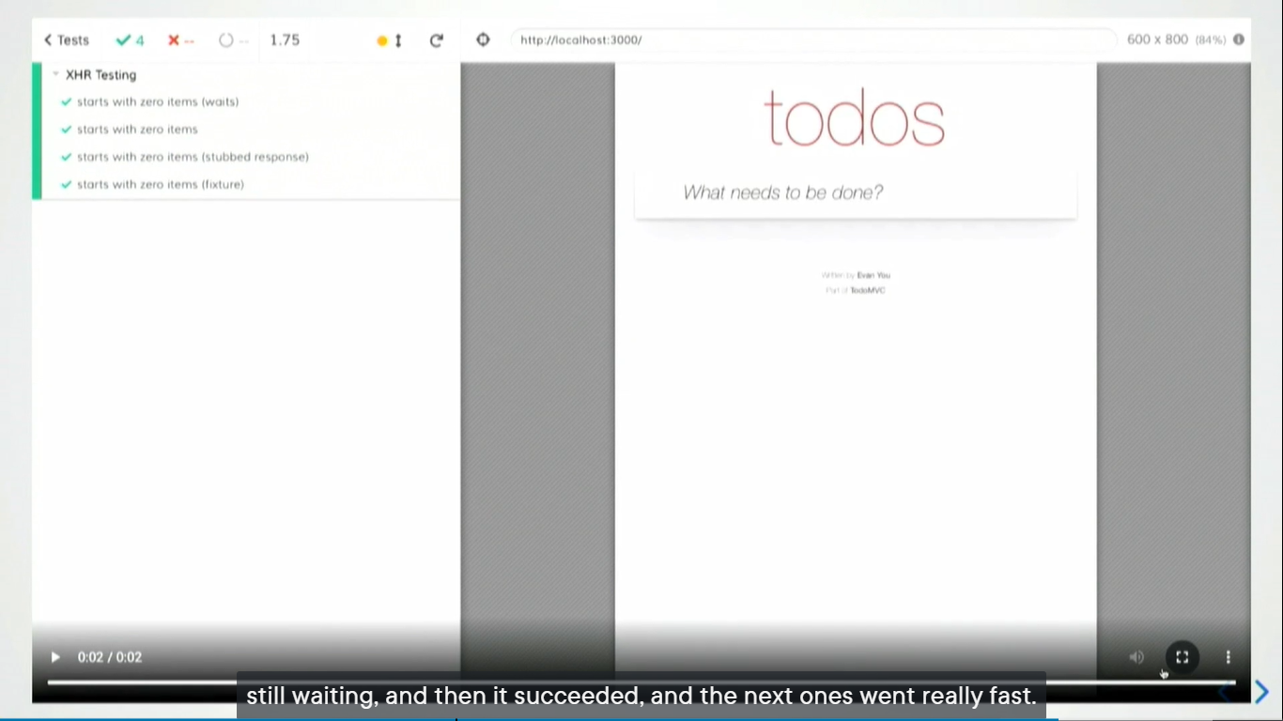

#### POST Request: Test the request got sent

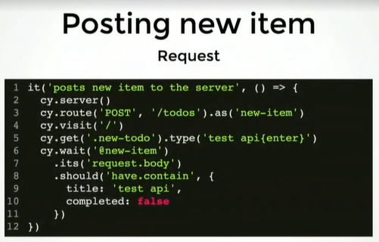

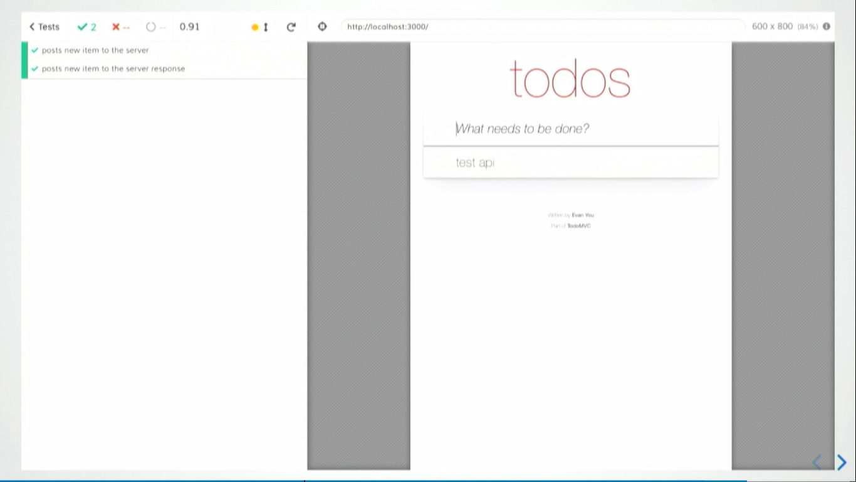

#### Loading Element